Controller Selection

There are different kinds of controller we have found and implemented in LTspice. The first one is, LT3751 which is capacitor charger. The main advantage of the controller is having an UVLO/OVLO pins what are used for the selecting input voltage range. Another advantage of the controller is that 2 resistors is used to setting up the output voltage which are RVout and RBG.

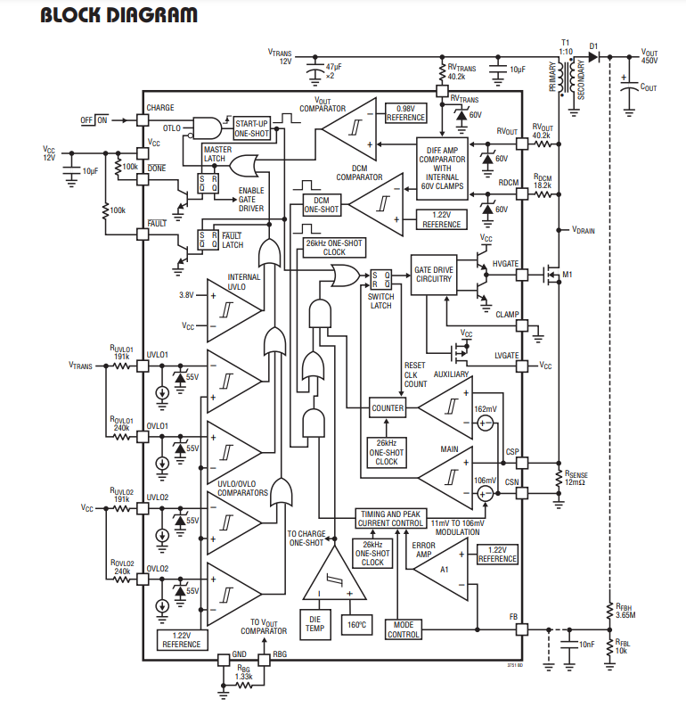

figure 1 Block diagram of the LT3751

Also, this controller has an ability to operate in DCM operation which is increasing the efficiency of the converter which is really critical for the project. At that point, most of the requirements for the project is satisfied, whereas this controller is used for capacitor charger which is emphasized at the beginning. Because of that, when this controller used with the load which is 5Ω in this project, output voltage decreased to zero. In this controller applications, output voltage regulation resistors exist for high output values. On the other hand, we are trying to regulate the voltage at the 15V and 45W output. In this step, we could not reach the required voltage level because of the step size of the controller. The reason behind this is the controller which is LT3751 is created for high voltage values. The digital voltage step size of the controller is higher than 15V.

After this controller, a lot of different kind of controller is implemented in LTspice and Simulink. Unfortunately, most of them could not reach the requirements that are specified in the project description. After the search step, we have found the LT3748 which is created by Linear technology. LT3748 is the isolated flyback converter controller. The advantages of this controller can be listed as:

-Wide input range and controllable lower threshold

-No transformer third winding or opto-isolator required for regulation

-Primary side winding feedback load regulation

-The LT3748 has different kinds of advantages besides those. The regulated output voltage can be decided as with the formula:

$$V_{FLBK}=\left(V_{out}+V_{F}+I_{sec}*ESR\right)*N_{PS}$$

$$\frac{V_{FLBK}}{R_{FB}}=\frac{V_{BG}}{R_{REF}}$$

$$V_{out}=V_{BG}*\left(\frac{R_{FB}}{R_{REF}}\right)*\left(\frac{1}{N_{PS}}\right)-V_{f}-I_{sec}*ESR$$

-Another advantage of the controller is indicating the inductance limitations which are upper and lower bounds for the transformer design. This part will be explained in the transformer design step.

$$\frac{V_{IN\left(MAX\right)}*R_{SENSE}*t_{ON\left(MIN\right)}}{V_{SENSE\left(MIN\right)}} ≤L_{PRI}≤\frac{V_{IN\left(MIN\right)}*(V_{OUT}+V_{F\left(DIODE\right)})*N_{PS}}{f_{SW\left(MIN\right)}*I_{LIM}*(\left(V_{OUT}+V_{F\left(DIODE\right)}\right)*N_{PS}+V_{IN\left(MIN\right)})}$$

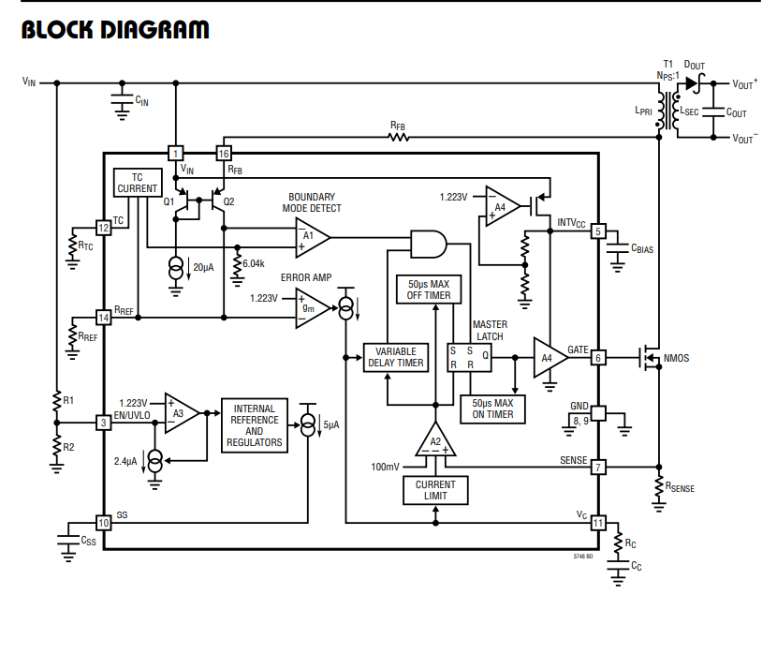

figure 2 Block diagram of the LT3748

The manufacturer of this controller which is Analog Devices has created the LTspice models for this chip. Thanks to that, we have implemented the schematic of flyback converter with LT3748.

Another chosen controller is LM51561 which is created by Texas Instruments. This controller is the second option for us. The advantages of this controller is wide and controllable input range, controllable output voltage, small size and low cost, constant peak current limiting over input. The features of the LM51561 is similar to the LT3748. Both of them ordered and the applications will be started with the LT3748.

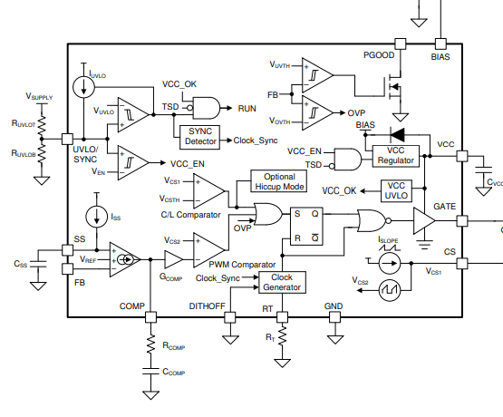

figure 3 Block diagram of the LM56511

Our last option for the controller is using STM32 or Arduino to control the converter. At this point, the controller designed as changing the DON and Doff time.

SNUBBER DESIGN

The voltage increase at the drain side of the mosfet, when the switch is off, appearing because of the leakage inductance of the transformer. When the current at the input side is high enough, more stored energy needs to be dissipated. Because of that, leakage inductances of the transformer need to be minimized. Considering the inadequacy or failure of the snubber circuitry, the VDS voltage rating of the MOSFET can be chosen with the safety margin. There are different kinds of snubber circuit design exist. One of the popular one is RCD snubber circuit. Another one is Zener snubber circuit. The advantage of the Zener suppressing circuit is dissipating the power when the voltage reaches the dangerous voltage level for the MOSFET.

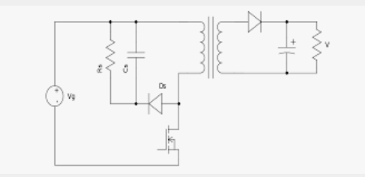

figure 4 RCD Snubber circuitry

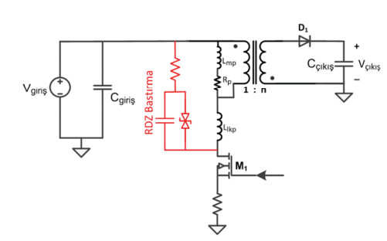

figure 5 Snubber Circuit with Zener Diode

The advised approach for designing the snubber circuitry, measuring the period of the ringing when the switch is off without snubber circuitry. After that, the snubber capacitor needs to be add the circuit starting from the feasible capacitance like 100pF. When the period of the damping reaches 1.5 -2 times longer, the capacitor is chosen. The change in period can determine the value of the parasitic capacitance and the initial period of the damping can determine the leakage inductance. In addition to that, those values can be determined from the leakage inductance of the transformer and switch capacitance. When this inductance and capacitance value is determined, the resistance of the snubber needs to be decided.

$$C_{PAR}=\frac{C_{SNUBBER}}{{\left(\frac{t_{PERIOD\left(SNUBBERED\right)}}{t_{PERIOD}}\right)}^{2}-1}$$

$$L_{PAR}=\frac{t_{PERIOD}^{2}}{C_{PAR}*4*π^{2}}$$

$$R_{SNUBBER}=\sqrt{\frac{L_{PAR}}{C_{PAR}}}$$

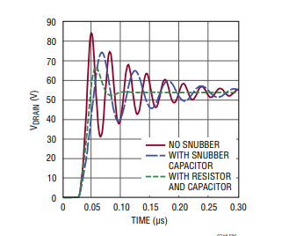

figure 6 Effect of the Snubber taken from the Datasheet of the LT3748

Dissipated power will be equal to:

$$P_{SNUBBER}=f_{SW}*C_{SNUBBER}*\frac{V_{DRAIN}^{2}}{2}$$